Reading Level 1:
The Berenstain Bears: Gone Fishin'!
By Mike Berenstain, Illustrated by Mike Berenstain
Short sentences, wide spacing between lines, large easy print, easily digestible words and concepts.

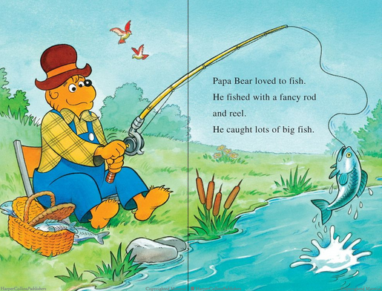

Reading Level 2:
Frog and Toad Storybook Treasury
By Arnold Lobel , Illustrated by Arnold Lobel
More words, still short sentences and spaces between lines, smaller font, easy concept with harder words.

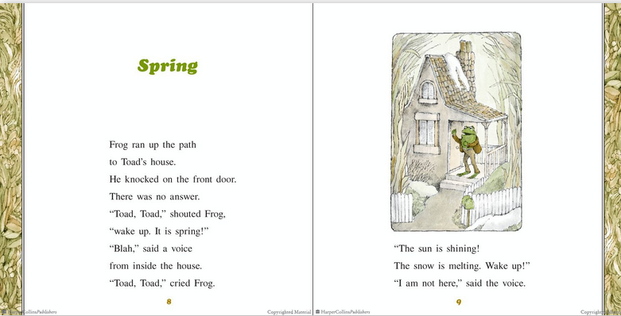

Reading Level 3:
My Parents Think I'm Sleeping
By Jack Prelutsky, Illustrated by Yossi Abolafia
Print is smaller, spacing between lines is still high, many more words, higher concepts, words are still fairly easy to digest.
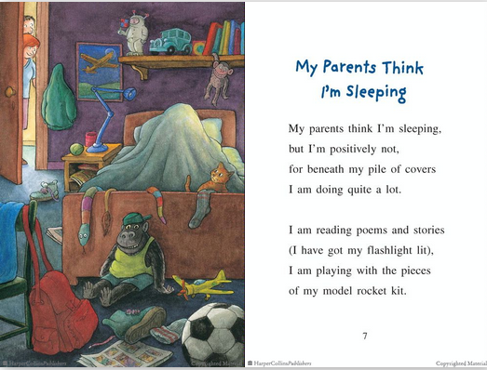

Reading Level Four:
Prairie School
By AVI, Illustrated by Bill Farnsworth
Much more like a chapter book with paragraphs, filled with long sentences, higher concepts, but still background pictures. The print is much smaller the sentences contain harder words sprinkled in.
